NeuroPrint
Brain Region Reference Guide
Trace the model with your finger, match what you feel to a region below, then flip the card for what it does.
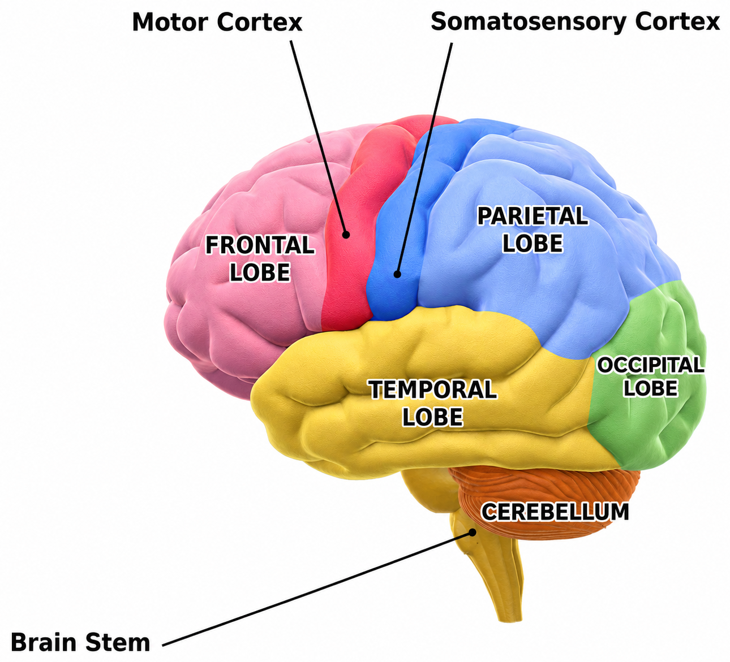
Diagram adapted from Blausen.com staff, Blausen Medical Communications — CC BY 3.0
neuroprint.info
Free 3D-printed brain models & teaching guides for schools and clinics

Brain Regions at a Glance
 | Frontal Lobe | Decision-making, planning, voluntary movement, and personality. | The last brain region to fully mature — development continues until about age 25.
 | Motor Cortex (Precentral Gyrus) | A strip along the back of the frontal lobe that plans and sends commands for voluntary muscle movement. | Body parts are mapped here by control precision, not size — hands and face take up far more space than the torso.
 | Somatosensory Cortex (Postcentral Gyrus) | A strip at the front of the parietal lobe that processes touch, temperature, and pressure from the body. | It sits directly behind the motor cortex, so ‘feel’ and ‘move’ signals are processed almost side by side.
 | Parietal Lobe | Integrates sensory information and supports spatial awareness and navigation. | Damage here can cause “neglect,” where a person stops noticing one whole side of their body or surroundings.
 | Temporal Lobe | Processes hearing and language comprehension, and supports memory formation. | The hippocampus, essential for forming new memories, is tucked inside this lobe.
 | Occipital Lobe | The brain's vision-processing center. | It sits at the very back of the brain, farthest from the eyes — yet it's where sight is actually “seen.”
 | Cerebellum | Coordinates balance, posture, and smooth, precise movement. | It's only about 10% of the brain's volume but holds more than half of all its neurons.
 | Brain Stem (Pons & Medulla) | Controls life-sustaining functions like breathing, heart rate, and sleep-wake cycles. | The oldest part of the brain evolutionarily — often called the brain's “life-support center.”
Why a model AND a card?
Learning research shows that pairing physical, hands-on exploration with a written reference strengthens retention more than either alone. Touching a structure builds a spatial memory of where it is; reading its name and function builds a verbal one — using this model and this card together links the two, so the information sticks from more than one direction.
NeuroPrint  Free 3D-printed brain models & teaching guides for schools and clinics.  Want more models, worksheets, or resources for your classroom? Visit neuroprint.info to request materials. | 